**1. ASUS ROG Zephyrus S Ultra Slim Gaming PC Laptop, 15.6” 144Hz IPS Type, Intel Core i7-8750H CPU, GeForce GTX 1070, 16GB DDR4, 512GB PCIe SSD, Military-Grade Metal Chassis, Win 10 Home - GX531GS-AH76**

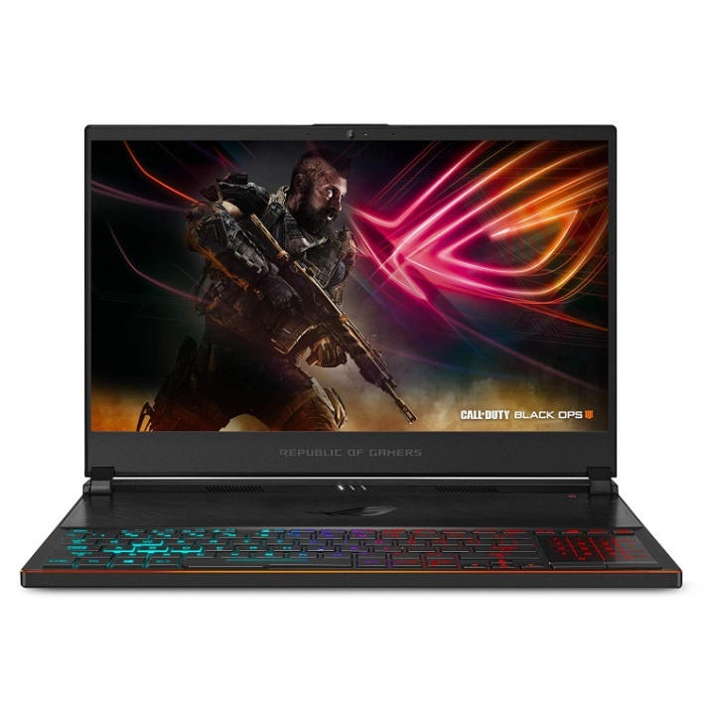

Precio: 1,589.99$

Descripcion:

15.6” Full HD 144Hz IPS Type Display | 3ms response time with slim 6.5mm Bezel

Nvidia GeForce GTX 1070 8GB GDDR5 *(with Max Q technology) | Base: 1101MHz, Boost: 1265MHz, TDP: 90W

8Th generation Intel Core i7 8750H (up to 3.9GHz) processor

0.62” thin, 4.6 lbs | ultraportable military grade magnesium alloy body gaming laptop with premium cover CNC milled from Solid aluminum

16GB 2666Hz DDR4 | 512GB PCIe NVMe M.2 SSD | Windows 10 Home

Rog active Aerodynamic System (AAs) | Upgraded 12V fans and anti dust tunnels to preserve cooling performance and system stability

Customizable 4 zone ASUS Aura RGB Gaming Keyboard

**2. Acer Predator Helios 300 Gaming Laptop PC, 15.6" FHD IPS w/ 144Hz Refresh, Intel i7-8750H, GTX 1060 6GB, 16GB DDR4, 256GB NVMe SSD, Aeroblade Metal Fans PH315-51-78NP**

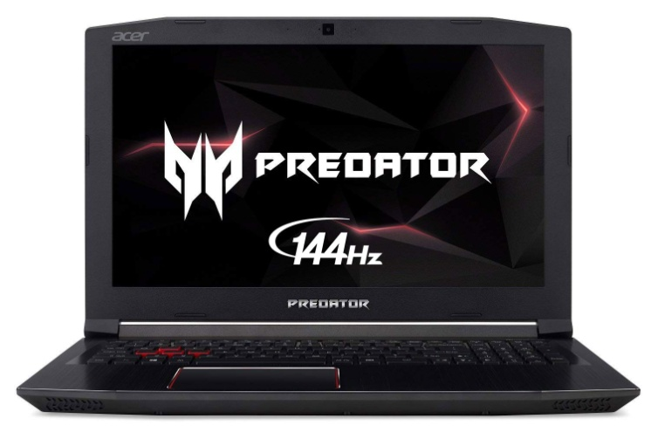

Precio: 968.32$

Descripcion:

8th Generation Intel Core i7-8750H 6-Core Processor (Up to 4.1GHz) with Windows 10 Home 64 Bit

NVIDIA GeForce GTX 1060 Overclockable Graphics with 6 GB of dedicated GDDR5 VRAM

15.6" Full HD (1920 x 1080) widescreen LED-backlit IPS display (144Hz Refresh Rate, 300nit Brightness & 72% NTSC )

16GB DDR4 2666MHz DRAM Memory & 256GB PCIe NVMe SSD | Extra empty accessible slot for 2.5 inch hard drive or SSD

Gigabit Wi-Fi |Backlit Keyboard | USB 3.1 (Type C) | Dual All-Metal AeroBlade 3D Fan Cooling | Metal Chassis.Battery Capacity:3320 mAh

Up to 7-hours of battery life

**3. MSI GL63 8RCS-060 15.6" Gaming Laptop, Intel Core i5-8300H, NVIDIA GTX1050, 8GB, 256GB Nvme SSD, Win10**

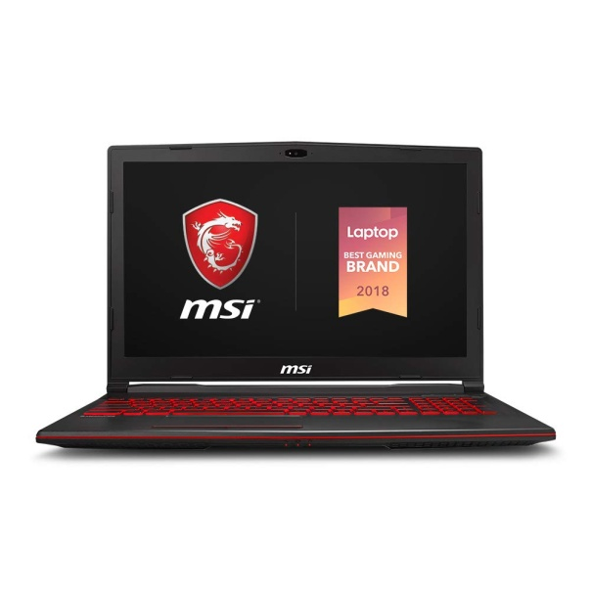

Precio: 624$

Descripcion:

Display: 15.6" Full HD eDP IPS-Level 45% NTSC

Processor: Core i5-8300H 2.3 - 4.0GHz

Graphics: NVIDIA GeForce GTX1050 4G GDDR5

Memory: 8GB (8G*1) DDR4 2666MHz, 2 Sockets; Max Memory 32GB

Storage: 256GB NVMe SSD ; Webcam - HD type (30fps@720p)

**4. 2019 Dell Alienware 17.3" FHD IPS High Performance Gaming Laptop | Intel Core i7-8750H Six-Core | 32GB DDR4 RAM | 512GB SSD Boot + 1TB HDD | GeForce GTX 1070 8GB | Backlit Keyboard | Windows 10**

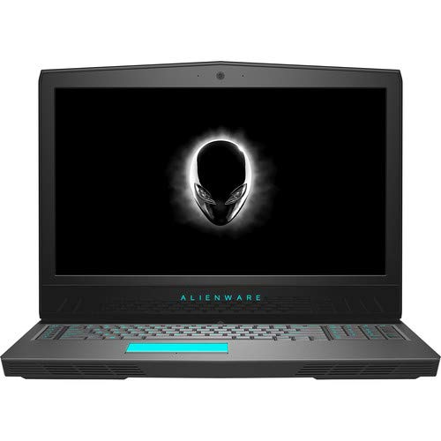

Precio: 1,917.07$

Descripcion:

* 8th Generation Intel Core i7-8750H Processor (6-Core, 9MB Cache, 2.2 GHz Up To 4.1GHz), 32GB DDR4 RAM, 512GB SSD Boot + 1TB HDD
* 17.3" Full HD (1920 x 1080) IPS Anti-Glare LED-Backlit Display, NVIDIA GeForce GTX 1070 OC with 8 GB GDDR5 VRAM
* 802.11a/b/g/n/ac (2x2), 10/100/1000 Gigabit Ethernet, Bluetooth 5.0, MaxxAudio, Webcam: 2.07 MP Photo / 1080p Video
* 1 x Thunderbolt 3, 1 x USB 3.1 Gen 2 Type-C, 2 x USB 3.1 Gen 1 Type-A, 1 x HDMI 2.0, 1 x Mini DisplayPort 1.3, 1 x Docking Connector, 1 x Combo Headphone / Microphone Jack, RJ-45 Ethernet
* Backlit Keyboard, Windows 10 Home, 6-Cell 99 Whr Battery, 9.74 lbs, Epic Silver